Job Description: Head of Research Support (Colleges of Engineering & Physical Sciences and Life & Environmental Sciences)

Post title and post number | Head of Research Support
College/Budget Centre | Research Strategy & Services Division
Terms and Conditions | Administrative and Other Related Academic staff
Job Family Framework | Managerial
Grade | Grade 9
Salary Range | £56,021 - £64,914 (with potential to consider up to £75k)

Background
The University of Birmingham is a global institution working within a diverse and vibrant City, offering an inspiring education to our students, and undertaking critically important research. We are a place of open, critical thinking, and the creation, sharing and dissemination of knowledge. Professional Services put students at the heart of all they do and enable an exceptional educational experience. They provide outstanding support to our researchers and help the University to grow its influence regionally, nationally, and globally. They ensure the University’s resources are used wisely, manage and improve the infrastructure which sits at the heart of the institution, and support decisions to be made quickly and based on sound evidence. Our Birmingham Professional programme operates across the University, supporting colleagues to network and collaborate, offering opportunities to learn and develop, contributing to the delivery of the University’s objectives, and helping everyone to understand the broader context within which we work.

Department overview
The University has an exciting vision to build on the success of REF2021, by continuing to transform its research performance across research awards, outputs, income, and impact. Central to this ambition is the Research Strategy & Services Division (RSSD), a new Professional Services department that has been established to provide a transformative and sector-leading approach to research strategy and support. The RSSD brings together into one connected eco-system professional staff that work within and across the following teams: Research Strategy & Development; Research Support (Grants & Contracts); Research Partnerships, Research Impact & Innovation; Research Policy & Environment; Research Systems & Data; Research Ethics, Governance and Integrity; Research Communications; Legal & Regulatory Compliance and Research Finance Accounting, as below:
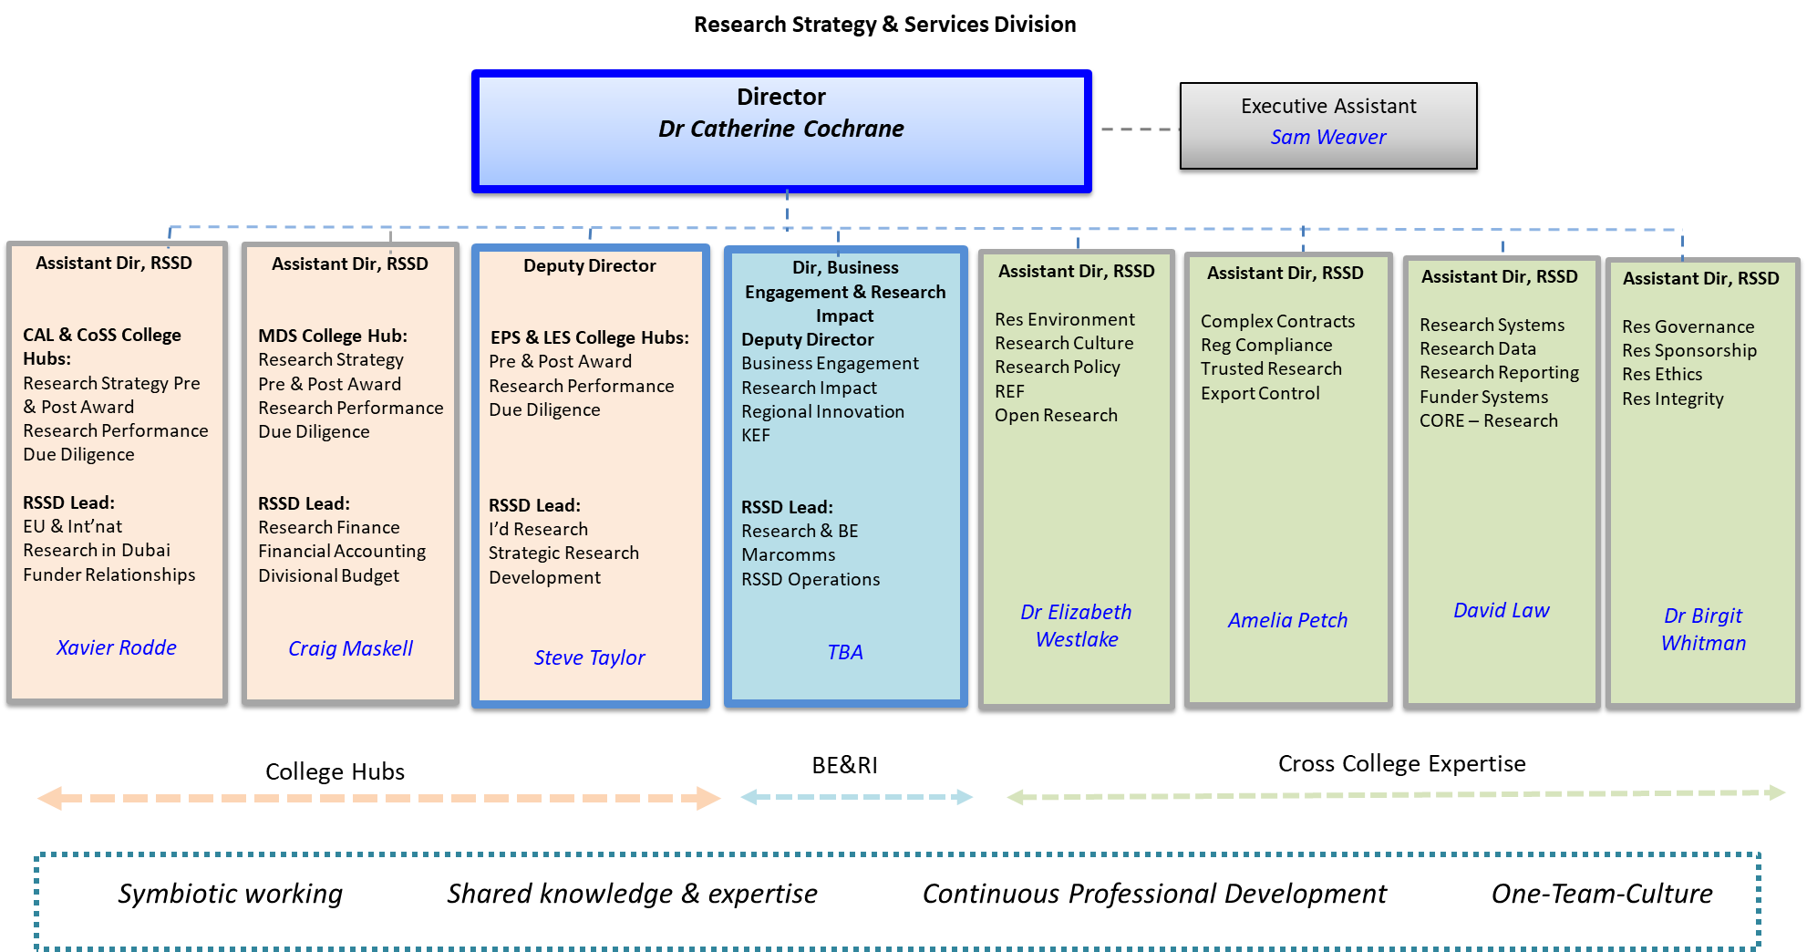

Role Summary
Reporting to the Deputy Director, RSSD, the Head of Research Support (Colleges of Engineering & Physical Sciences and Life & Environmental Sciences) leads one of our three College Hub Research Support teams, encompassing all aspects of pre-award research support, grants set up and contracts. This includes due diligence checks of external partners, funder terms and conditions and contracting terms and conditions.
Working alongside the Heads of Research Support are the Research Strategy & Development Teams, who lead on the development of cross-college inter-disciplinary bids and strategic regional proposals, and the Heads of Post Award delivering post award management to successful grants and contracts. Most recently, a dedicated Trusted Research function has been developed to lead on Export Control, provide guidance to the College Hubs on complex contracts, and deliver regular training sessions to the Hubs on all matters related to Trusted Research.
The RSSD is committed to a collaborative and open culture, and the Head of Research Support will benefit from this and will embed this same culture within their College Hub Research Support team to ensure that colleagues are supported and work collectively.
The post holder will work alongside colleagues from the wider RSSD and the Colleges to develop and lead research support teams that will provide comprehensive pre-award support for researchers across research development, research support and facilitation, contracts and research-related agreements.
The post holder will lead a team that takes a risk-based approach to managing its portfolio, supported by a team of three Research Support Managers who each have responsibility for a defined set of Schools within the two Colleges.
Being approachable and open to staff within the RSSD and the wider University is a key element of the role, reflecting the collaborative approach that is essential to effective research support. Key internal stakeholders include academics, College Heads, Directors of Research and Directors of Operations, and the Head of Research Support will also have the opportunity to develop relationships with strategic partners, funders and HEIs from across the sector.
Organisational Chart
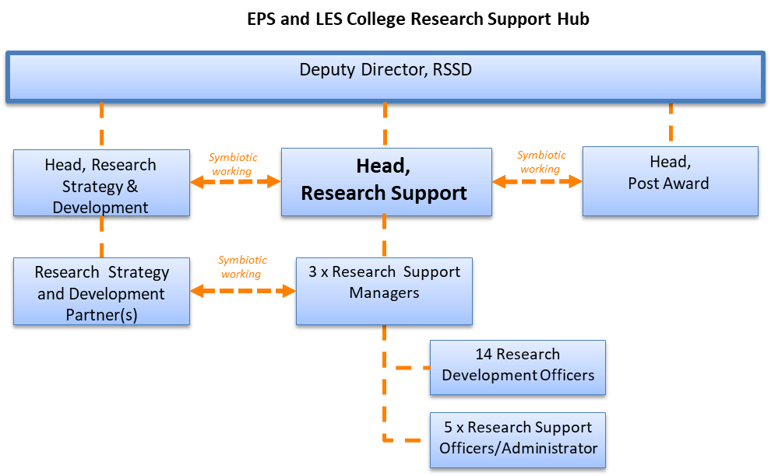
Main duties
- Working with your team of Research Support Managers, lead a Research Support Team of between 20-25 practitioners to effectively manage and agree prioritisation of workload across all aspects of pre-award research support including: research development; research facilitation and support for proposal drafting; budget preparation and costing; compliance with funder terms and conditions; submissions to funder; regulatory compliance and trusted research, including due diligence on partners and funders and referrals for export control; grant set up; negotiation and agreement of research contracts and research-related agreements.

- With your RSMs, ensure timely monitoring and reporting to senior colleagues in RSSD and the College of key performance indicators including grant applications, awards, contribution, success rates and contracts clearance levels. Develop and lead innovations in research support that seek to enhance these measures and ensure that the impact of service innovations is clearly understood, that systemic issues are recognised and addressed, teams are supported to effectively deliver, and services are continually improved.

- As a contracts signatory for the University, ensure that there is a clear negotiating framework for all research and research related contracts, that is regularly reviewed and updated, which supports the negotiation of all agreements relating to research, ensuring that this includes appropriate provision for the protection of Intellectual Property, the effective transfer and protection of data including highly sensitive data, the right to publish academic work, and the recovery of appropriate funds to support research to support the overall financial position of the Colleges and University. Developing staff within the team to do the same, ensuring a strong, proportionate and risk-based approach to research contracting at the University. These agreements will include: industry-funded contract research, collaboration agreements, material transfer agreements, confidentiality/non-disclosure agreements and may also include sponsorship agreements, and site agreements.

- To support teams with the more complex research applications and contracts as and when required, leading on such projects whilst providing team members the opportunity to develop their own skills in this regard via close working and ongoing mentorship in a culture of continuous professional development.

- Working closely with senior Professional Services colleagues, ensure that approved research applications can progress effectively through the University’s Finance, HR, and Procurement systems, in support of the RSSD’s role as the functional lead for research at the University and significantly improving the satisfaction of academics with the overall research support services at the University, to enable research to happen in an effective and efficient way.

- Develop strong external networks across the Russell Group, professional bodies and wider sector to ensure the delivery of best practice at Birmingham. Empower the team to do the same, ensuring that the University is well connected and influential with major funders, partners, and collaborators from public sector, industry and policy organisations.

- Develop and embed a strong culture of collaboration, information and data sharing, and symbiotic working across the team to provide an agile, responsive and customer-focused service to researchers, external partners, and funders, to support the research ambitions of the College and the wider University in line with the Strategic Framework.

- Be responsible for HR matters within the team, leading and developing staff and ensuring that the recruitment, development and retention of highly capable staff is supported by clear development/career plans and performance processes and providing active support for, and leadership of, EDI matters.

- Bring innovative and creative solutions to the work of the Research Strategy & Services Division and to lead programmes of change that deliver service improvement to the Division and which supports the University’s sustainability agenda through resource efficient working.

- Act as an ambassador for the University, upholding and promoting the University’s values and interests and deputising for the Deputy Director as required in high level delegations to campus from senior, board level representatives of major funders and partners ensuring that the University builds strong and effective partnerships in the pursuit of research income, impact, and influence.
- Develops and implements a culture (including policies and procedures) that promotes equality and values diversity and inclusion.

- Any other duties commensurate with the grade, as required from time-to-time by the Deputy Director.

Required Knowledge, Skills, Qualifications, Experience

- Educated to Degree level (or equivalent level qualifications), or extensive experience of working in a complex organisation plus substantial relevant managerial experience.
- Experience of drafting and reviewing complex research agreements using a pragmatic and risk-based approach.
- Ability to exercise a substantial degree of independent professional responsibility and discretion.
- Ability to lead and manage diverse groups of staff through intermediate managers.
- A strong knowledge of, and interest in, national and international research policy and operations.
- Strong empathy for the academic endeavour at a research-intensive university and the ability to develop strong partnerships with senior leadership across the institution.
- Significant experience of providing senior practitioner support to complex issues relating to research contracts, compliance with funders terms, trusted research, research governance, research culture, and being recognised as a trusted expert and developing individuals and teams to do the same.
- Knowledge and experience of research funding and facilitation.
- Significant experience of leading and/or co-ordinating large, strategic partnerships that involve universities, public sector bodies, policy organisations, and industry.
- Excellent literacy and numeracy, with the ability to write for different audiences and for different purposes, and to produce and analyse complex source material, information and data.
- Actively promotes equality and diversity to internal and external stakeholders.
- Able to use data to identify, and develop interventions to address, equality and diversity issues

Role context
Roles at this level will be senior professionals with high-level expertise, exercising within their particular functional area/section a substantial degree of independent professional responsibility and discretion, including the development and implementation of policies and processes. You are expected to resolve problems where there is a lack of precedent, requiring innovation and creativity to develop appropriate options. You will be responsible for setting quality and professional standards and managing service. Your work has a medium to long term horizon and you will work with a variety of people from several teams. You will also be able to make a major contribution to the longer-term strategic planning for your area, in line with the wider University strategy.

Core competencies/transferable skills
Working at this level you will be able to develop and successfully demonstrate the core competencies/transferable skills outlined in each of the areas shown below. You will be expected to take ownership for getting things done, including calling on others to join you in collaborative working groups as necessary. You will need to be flexible in supporting your department and wider University.

Planning and organising
- lead and manage a functional area, taking responsibility for staff and resources, tackling planning and operations over the medium to long term;
- shape strategic direction for own area, and make significant contributions to departmental strategic planning;
- set quality and professional standards for others;
- take accountability for the quality and delivery of a service or for the provision of expert professional advice;
- take the initiative and manage large-scale changes;
- make decisions and judgements on conflicting data/information;
- as appropriate, research and develop drafts of papers, taking account of the final audience, socialising ideas and seeking input and producing final drafts;
- lead and manage projects which are complex and significant in terms of time and financial resources.

Problem solving and decision making
- evaluate service provision and implement innovative solutions to improve quality, efficiency and continuity;
- ensure effective resolution of all issues in own area, often requiring complex problem solving through others;
- identify trends which could have an impact on the area, and identify and implement approaches to these trends;
- deal effectively and sensitively with significant and substantial people management issues, such as major change programmes and lead staff through change whilst maintaining motivation.

Organisational understanding
- quickly develop an in-depth understanding of their own area and an excellent understanding of the contribution other areas make to success of the University;
- quickly develop an excellent understanding of how the University and academia operate in the UK (and beyond as appropriate);
- demonstrate empathy with the academic endeavour and encourages others to do so.

Relationships and communication
- interact effectively at senior levels within the University;
- network with fellow professionals in the wider community to stay up to date;
- promote own/department’s work at internal and external opportunities;
- inspire and motivate others (often large teams) through multiple intermediary managers;
- provide expert input for internal/external meetings, influencing and facilitating different opinions to reach consensus;
- consult with service users/others to establish service requirements, standards and priorities for change.

Our Shared Values

Ambitious  We are confident in the University of Birmingham and project this globally. We are focused on our goals, are clear about our strengths, and pursue our own direction. We are bold and take intelligent risks. | Innovative  We enjoy being the first to do things. Inspired by our Birmingham heritage, we are resourceful, creative, grounded, and practical, and seek to make a real and positive difference to the world around us. | Open  We welcome colleagues, collaborators, and students from across the world to work and study with us. We are committed to academic freedom, freedom of speech, and equality of opportunity for all. We expect everyone to act with sensitivity, respect, and fairness. | Collaborative  The major challenges facing our city, nation, and the world cannot be solved if we act alone. We enhance our research and education by pursuing creative partnerships within and beyond the University. | Responsible  We operate with transparency, trust, and respect. We value our role as an anchor institution for Birmingham. We strive to be an excellent employer, to reduce inequalities in access to education, and to place sustainability at the heart of our work.

