Information Pack
Director MRC Lifecourse Epidemiology Centre

Post title: | Professor and Director of the MRC Lifecourse Epidemiology Centre
School: | Human Development and Health
Faculty: | Medicine
Career Pathway: | Clinical / ERE Balanced | Level: | Consultant / Level 7 Pathway dependant
Associated NHS Trust | University Hospital Southampton NHS Foundation Trust (UHS)
Clinical category: | Balanced portfolio
Posts responsible to: | Dean of Medicine  Medical Research Council (MRC)
Posts responsible for: | Senior academic staff within the MRC LEC, including programme leads staff appointed to deliver the Directors own research portfolio and members of professional services staff (finance, HR, IT, estates and administration) appointed to ensure smooth delivery of the MRC LEC academic mission. PS staff will work closely with the Director to deliver the Centre mission and will each have a faculty based PS line manager.

Particulars of Appointment

The MRC and the University have agreed a University-led appointment process for the appointment of Director of the Lifecourse Epidemiology Centre (LEC). An MRC representative may be part of the interview panel to provide a link to MRC if appropriate. The recommendations of the Appointments Panel will be subjected to approval by the MRC and the University.

On appointment the Director will be a member of the University’s academic staff unless the MRC
otherwise agrees in writing. The University shall ensure that the Director shall enter into an
agreement with the MRC in respect of the Director’s responsibilities to the MRC.

The Director shall have the status and responsibilities within the University to enable them to
fulfil all responsibilities assigned. The University shall ensure that the Director shall provide
focussed scientific and management leadership consistent with the hours employed for the role.

The University shall authorise and require the Director to deliver the strategy agreed with the MRC
The Director will be advised on the overall strategy and deployment of resources by a Steering
committee /advisory group ("Committee"). The chair, membership and terms of reference of the
Committee will be agreed between the MRC, the University and the Director. An MRC representative
(Programme manager) will have the opportunity to attend the steering committee/advisory group as
an observer.

The University of Southampton

The University of Southampton is a leading research-intensive University, a member of the Russell Group and one of the top 100 universities worldwide. We deliver an excellent educational experience, world-leading research and we are known for successfully commercialising that research through enterprise.

This is an exciting time to join the University of Southampton. We have an aspirational University Strategy (see www.southampton.ac.uk/strategy), setting out our ambitions over the next five years. The strategy involves achieving a top 10 place in the UK for research, which we will achieve by investing in the highest quality staff and facilities. We are also transforming the education offer available to undergraduate and postgraduate students across the University, providing greater flexibility and modular courses, with a strong international focus.

The Faculty of Medicine

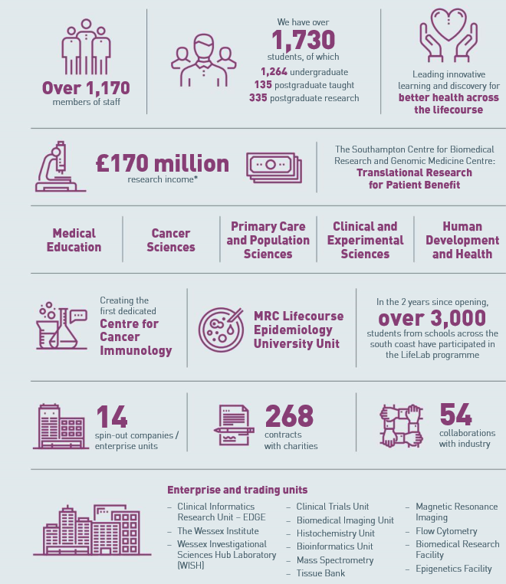

The creation of the Faculty of Medicine (FoM) has enabled us to build upon strong foundations of basic research and clinical translation. The Director of the MRC Centre will have a senior leadership role in the Faculty as a member of the Faculty Executive Board and play a key role in delivering our ambitious targets for growth and impact in research and knowledge exchange. Working in partnership with colleagues across the University, NHS partners and the wider health and technology ecosystem we have a national position as a renowned centre for translational research, leading innovative learning and discovery for better health across the life-course. The MRC Centre is an important component of our science infrastructure and the Director will lead the MRC Lifecourse Epidemiology Centre in delivering the existing programme of lifecourse epidemiological methods to reduce the population burden of chronic musculoskeletal disease and disability, and to further develop a cross disciplinary ambitious programme of research that will be competitive for a future application to the MRC’s new funding model for Centres of Excellence.

Key to the success of the Faculty of Medicine is the delivery of high-quality education for undergraduate and postgraduate students, training our future clinical and non-clinical academic leaders and building on our partnership in biomedical research with University Hospital Southampton NHS Foundation Trust. The interdisciplinary focus within the University encourages and enables the fostering of new interdisciplinary collaborations including for example engineering and computer sciences. The recent development of Wessex Health Partners (Academic Health Sciences Centre) is adding strength and opportunity, through even greater diversity of ideas and research capability, that delivers greater impact from research outputs at speed across the wider Wessex Region and beyond.

Research and Enterprise

The Faculty of Medicine delivers a triple helix of excellence with world class research, innovative education and a far-reaching portfolio of enterprise. We have an ambitious strategy for growth and sustainability that supports our staff and students to develop rewarding careers that make best use of their individual skills and aptitudes.

The Faculty of Medicine Enterprise Strategy is fully aligned to the University Enterprise Strategy to provide a step change to its enterprise and innovation culture, delivering global outreach, community engagement, innovative healthcare and policy. We work with all stakeholders from industry and pharma to health providers and the community contributing added value for our civic university.

The Student Experience

We offer a range of undergraduate programmes: the BM4 programme, a graduate-entry four-year programme which accepts 50 students per year; and the BM5 and BMedSc programme which accepts 210 students per year including approximately 30 students from our widening access BM6 programme. Science teaching in the first three years of the BM programmes is delivered in the South Block of Southampton General Hospital as well as the Life Sciences Building on Highfield Campus and all students undertake a year 3 research project. There is also the opportunity, for selected students, to undertake an integrated, intercalated Masters in Medical Science (MMedSc). Clinical teaching takes place at University Hospital Southampton and in later years in partner NHS hospitals across the Wessex region and beyond.

In addition to the undergraduate BM programmes the Faculty provides Masters Degree programmes in Public Health, Allergy and Genomic Medicine and an intercalated MMedSci for medical students.

Equality, Diversity and Inclusivity

We are committed to positively advancing equality of opportunity. We participate in a number of equality initiatives which celebrate good employment practice for the advancement of diversity, equality and inclusivity. These include the Stonewall Workplace Equality Index, the Race Equality Charter and Athena Swan. We have a Silver Faculty Award (renewed in 2020) and a Silver Institutional award (renewed in 2021), we are one of only 19 Universities with this level of award. We have a Faculty level equality committee who champion the advancement of equalities for diverse groups and each school has an EDI committee reporting into the faculty committee.

Southampton Behaviours

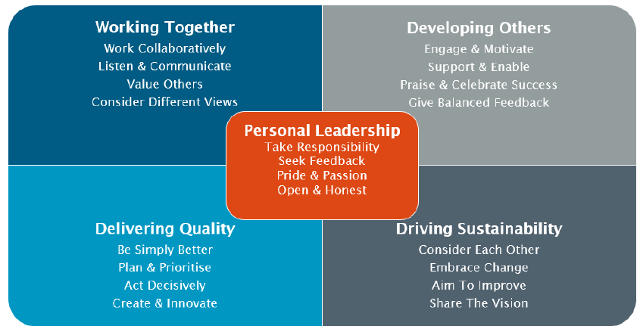

Medical Research Council Lifecourse Epidemiology Centre

The agreed mission of the MRC Lifecourse Epidemiology Centre (the “Centre”) is to use lifecourse epidemiological methods to reduce the population burden of chronic musculoskeletal disease and disability.

Specifically, the Centre’s strategy is directed at optimising musculoskeletal health (bone, muscle and joint) through the development and testing of lifestyle, behavioural and pharmacological interventions informed by observational studies and mechanistic understanding, using these findings to influence health policy.

The Centre Grant currently operates for 5 years from 01/07/202. The Director will be expected to develop a competitive programme of research activity in line with the new 14-year funding model that is emerging, thereby securing the future of this visionary and interdisciplinary unit.

Within the agreed remit, the Director is expected to develop the scientific programme of the Centre and meet agreed milestones for the delivery of research and training output. The Director should support innovation in areas relevant to the Centre’s themes, including seeking additional funding from MRC (through, for example, research grants), the University or other funding bodies, to take account of advancing knowledge and the emergence of new opportunities.

Over the current funded period 2021-2026 the Director is specifically expected to facilitate the following changes / developments:

- Delineate the environmental influences, throughout the lifecourse, of age-related musculoskeletal diseases (osteoporosis, osteoarthritis and sarcopenia).
- Use findings to develop and test population based and targeted interventions to improve musculoskeletal health throughout the lifecourse.
- Maintain and develop the long-term cohorts/trials assembled in Southampton as national and
international resources to explore the mechanisms underlying the developmental origins and later causes of musculoskeletal and metabolic health and disease.
- Minimise the adverse impact of musculoskeletal disorders on ability to work.
- Inform health policy and promote training, research capacity development, knowledge transfer and public engagement in lifecourse epidemiology.

The Centre shall be “research led” and the scientific programmes of the Centre shall evolve
during the period(s) of the award. A key objective of the Centre is its development as a high-quality environment for research training. The Centre shall be able to access funding for PhD Studentships from Doctoral Training Partnership (DTP) and other allocations to the University. The Centre can also bid for an additional allocation of funding for Studentships as part of the Centre's application for funding.

University Hospital Southampton NHS Foundation Trust (UHS)

University Hospital Southampton NHS Foundation Trust provides services to some 1.9 million people living in Southampton and south Hampshire, plus specialist services such as neurosciences, cardiac services and children's intensive care to more than 3.7 million people in central southern England and the Channel Islands.
The Trust is also a major centre for teaching and research in association with the University of Southampton and partners including the Medical Research Council and Wellcome Trust.
UHS gained Foundation Trust status on 1 October 2011.
Every year 11,500 UHS staff:
- treat around 150,000 inpatients and day patients, including about 50,000 emergency admissions;
- see over 624,000 people at outpatient appointments; and
- deal with around 135,000 cases in there emergency department.
Providing these services costs £1.9 million a day.

Principal Duties of the post

The principal purpose of this post is to direct the strategy and research activities within the MRC LEC ensuring that the centre delivers the objectives and impact set out for the quinquennium 2021-2026. Furthermore, the Director will work together with current programme leads to develop the future vision and strategy for a Centre of Excellence post-2026. The Director will be responsible for oversight of all the programmes within the Centre and ensuring that additional external funding for research is delivered to grow the research portfolio and ensure world class impact. The post is supported by Professional Services providing bespoke IT, estates, financial and administrative personnel to ensure the smooth running of the centre which is accommodated in its own building adjacent to the medical school at the southern end of the University Hospital Southampton campus.

Teaching and training
The Director will ensure that staff within the centre contribute to the education and training of undergraduate medical students, post-graduate taught and Post Graduate Research students both in the Faculty of Medicine and from related disciplines where the work of the centre aligns. We encourage interdisciplinary exchange of students and trainees.

Honorary Clinical Contract (if applicable)
If the post holder is clinically qualified, they can choose to deliver clinical service at University Hospital Southampton in agreement with the University. For clinically active Professorial staff, the hospital will issue an honorary clinical contract, ensure that annual job planning and appraisal is conducted and oversee revalidation with the General Medical Council.

Director MRC Lifecourse Epidemiology Centre
Job Description and Person Specification
Job purpose
Accountable jointly to the MRC and the University for all aspects of the management of the Centre, the Director will provide direction and leadership upholding the agreed mission of the MRC Lifecourse Epidemiology Centre (the “Centre”) to use lifecourse epidemiological methods to reduce the population burden of chronic musculoskeletal disease and disability.

Responsibility for the overall direction, management and quality of the Centre’s scientific programmes.

Key accountabilities/primary responsibilities |  | % Time
 | Strategic Leadership  Provide visible and inspirational leadership for the MRC at all levels and within the University. Ensuring the effective and efficient delivery of the Centre requirements.  Engage regularly with Faculty and University Leaders and the MRC Committee building relationships and trust to develop and support the MRC agreed mission and strategic direction. | 30
 | Strategic Development  Develop the scientific programme of the Centre and meet agreed milestones for the delivery of research and training output. Support innovation in areas relevant to the Centre’s themes, including seeking additional funding from MRC, and other research funding bodies, the University and industry partners,  taking account of advancing knowledge and the emergence of new opportunities.  Develop and maintain a high-quality environment for research training, identifying new programmes which take forward the mission of the Centre and deliver the strategy agreed with MRC. Support bids for funding for PhD studentships from a range of funding source to complement and expand the Centre studentships.  Delineate the environmental influences, throughout the lifecourse, of age-related musculoskeletal diseases (osteoporosis, osteoarthritis and sarcopenia). Use findings to develop and test population based and targeted interventions to improve musculoskeletal health throughout the lifecourse.  Maintain and develop the long-term cohorts/trials assembled in Southampton as national and international resources to explore the mechanisms underlying the developmental origins and later causes of musculoskeletal and metabolic health and disease.  Develop the vision, strategy and objectives to ensure a competitive application for funding via the MRC Unit model to secure a future MRC Centre from 2026. | 40
 | Performance Management  Provide focussed scientific and management leadership for the centre. Ensure the integration of constituent teams, to enable the Centre to meet the objectives of multi-disciplinary and added value.  Provide effective day-to-day management of the Centre, its financial resources, staff, students and visiting and attached workers - with the support of the appropriate University officers. Ensure accurate and up to date records are maintained in relation to (but not exclusively) publications, findings, employment records, funding, resources and key decisions. | 10
 | Governance and Compliance  Report as required to the University and MRC on the progress and performance of the Centre according to the agreed milestones and goals. Record the agreed metrics of success of the Centre and submit progress reports, disseminating as appropriate. | 5
 | Stakeholder Engagement  Represent the Centre within the School, Faculty and University and the MRC community, nationally and internationally. Engage with the public to promote public dialogue and encourage and facilitate public engagement.  Inform health policy and promote training, research capacity development, knowledge transfer and public engagement in lifecourse epidemiology.  Work with the University and/or MRC contact/s in the UKRI Press Office to draft and disseminate press releases, media statements or media briefings. Clear all press releases/statements which refer to the MRC, MRC staff, or work funded or part-funded by the MRC Centre, with the UKRI Press Office. | 10
 | Any other duties that fall within the scope of the post as allocated by the line manager following consultation with the postholder. | 5

Key accountabilities/primary responsibilities – Clinical |  | % Time
 | To be discussed and agreed with the Dean of the Faculty of Medicine and the UHS Chief Medical Officer on appointment.

Internal and external relationships
- UKRI Medical Research Council including Chief Executive and Chief Scientific Office
- PSMB Programme Manager
- MRC LEC Steering Committee
- The President and Vice-Chancellor, Senior VP Academic and VP Research and Enterprise, Deans of the five Faculties and other senior leaders within the University where relevant
- The Faculty of Medicine Executive Board
- The Chief Executive and Chief Medical Officers of UHSFT if clinically active
- The Directors of the NIHR Biomedical Research Centre and the Applied Research Collaboration
- The Chairperson of the strategy Board for Wessex Health Partners Academic Health Sciences Centre
- The Director of the Institute for Life Sciences University of Southampton
- Head of School of Human Development and Health
- UKRI press office
- The general public

Special Requirements
- Attend national and international conferences as appropriate.
- Contribute to the effectiveness of the Faculty of Medicine as an active member of the Faculty Executive Board and through regular contact with the Dean of Medicine.
- Contribute to the missions of the University and the MRC through personal contribution and leadership style and by ‘living’ the University and MRC’s core values and principles.
- Assure an amicable and effective working relationship between the MRC LEC and the rest of the School of HDH
- Promote a culture of equality, inclusivity and respect.

Appraisal
Annual appraisal is expected and if clinically active mandated by the GMC. Appraisal will follow University guidelines, and clinically active appraisal will follow Follett principles for joint clinical/academic appraisal meeting according to the nationally agreed process where annual appraisal meetings involve a UHS Trust appraiser and the University line manager or their nominee. This carries an expectation of active involvement in audit, continuing professional development and revalidation in line with best practice in clinical governance.

The UHS Trust has a range of mandatory training and competence initiatives which are reviewed on a regular basis. Appointees are required to register and participate in these programmes (mainly via e-learning and assessment).

Staff Benefits
Working at the University of Southampton gives you access to a wide range of benefits in addition to our competitive rates of pay. Our core benefits include pension scheme membership; a generous annual leave allowance (supplemented by University closure days and public holidays) and excellent family leave arrangements (including maternity, paternity, adoption and parental leave).

- Ability to remain in NHS pension scheme, subject to qualifying criteria;
- Discounted Sport and Wellbeing membership;
- Access to private dental and/or healthcare insurance;
- Cycle to work scheme
- Tax-Free childcare

PERSON SPECIFICATION

Criteria | Essential | Desirable | How to be assessed
Qualifications, knowledge and experience | Primary medical or other relevant degree plus PhD or equivalent professional qualifications  A proven track record of outstanding academic achievement, of international standing, in a field of expertise relevant to the centre.  A proven track record of providing strategic and visionary direction and maximising performance in a complex organisation.  Able to make a substantial contribution to the UKRI Research Excellence Framework (REF).  Experience of managing an academic group or department.  Experience in supervision of doctoral students. | Fellow of Higher Education Academy  Membership of national or international advisory bodies in musculoskeletal health.  Expertise recognised by membership of a relevant prestigious society or organisation. | Third party confirmation  CV and references  Interview  Application  Application and interview  Application and interview
Planning and organising | Proven ability to develop innovative research proposals and attract research funding.  Proven ability to lead, plan and develop a range of high-quality research and teaching activities, ensuring plans complement the broader research and education strategy of the Faculty and University.  Proven ability to engage with and influence policy makers and implement research evidence in healthcare  Proven ability to champion and oversee key contributions of the MRC LEC mission to the faculty of medicine and/or University research, education and enterprise strategies. | Ability to design and manage a post-graduate degree programme.  Teaching qualification (PCAP or equivalent).  Proven ability in curriculum development and new teaching approaches. | Interview  Interview  Interview  Interview
Problem solving and initiative | Proven ability to implement successful change management initiatives and formulate strategic plans that reflect and support the priority needs of the centre, faculty and University.  Proven ability to identify broad trends to assess deep-rooted and complex issues.  Demonstrable ability of applying originality in modifying existing approaches to solve problems. |  | Interview  Interview  Interview
Management and teamwork | Proven ability to oversee people and resource management processes in order to deliver key education, research and enterprise activities.  Proven ability to make a sustained contribution to academic leadership at discipline, School and faculty level.  Work effectively in a team, understanding the strengths and weaknesses of others to help teamwork development.  Demonstrable experience of ability to formulate staff development plans.  Able to undertake coordinating role in school/university or externally.  Experience of monitoring and managing resources and budgets. |  | References and Interview  Interview  Interview  Interview  Interview  Interview
Communicating and influencing | Highly developed interpersonal and communication skills and the ability to influence, collaborate and interact effectively with a range of stakeholders including staff (at all levels and within multiple disciplines), students and external stakeholders.  Demonstrable ability to persuade and influence at all levels in order to foster and maintain relationships, resolving tensions/difficulties as they arise.  Proven experience of providing expert guidance to colleagues in own team, other work areas and institutions to develop understanding and resolve complex problems.  Communicate new and complex information effectively, both verbally and in writing, engaging the interest and enthusiasm of the target audience including public engagement.  Proven experience of engaging counselling skills and pastoral care, where appropriate.  The ability to cultivate strong networks and build links with the wider community and with business, industry and other stakeholders and to represent the Medical Research Council and the University nationally and internationally. |  | Interview and Presentation  Interview  Interview  Interview and presentation  Interview  Interview
Other skills and behaviours | Compliance with relevant Health and Safety issues.  Apply and actively promote equality, diversity and inclusion principles to the responsibilities of the role.  As a Line Manager role model the Southampton Behaviours and work with the management team to embed them as a way of working within the MRC centre and wider faculty. |  | Interview  Interview  Interview
Special requirements | Able to work outside of normal office hours and at off-campus locations.  Able to attend national and international conferences to present research results. |  | Interview

Appendix 1. Embedding Collegiality

Collegiality represents one of the four core principles of the University; Collegiality, Quality, Internationalisation and Sustainability. Our Southampton Behaviours set out our expectations of all staff across the University to support the achievement of our strategy.

All staff | Behaviour
Personal Leadership | I take personal responsibility for my own actions and an active approach towards my development
 | I reflect on my own behaviour, actively seek feedback and adapt my behaviour accordingly
 | I show pride, passion and enthusiasm for our University community
 | I demonstrate respect and build trust with an open and honest approach
Working Together | I work collaboratively and build productive relationships across our University and beyond
 | I actively listen to others and communicate clearly and appropriately with everyone
 | I take an inclusive approach, value the differences that people bring and encourage others to contribute and flourish
 | I proactively work through challenge and conflict, considering others’ views to achieve positive and productive outcomes
Developing Others | I help to create an environment that engages and motivates others
 | I take time to support and enable people to be the best they can
 | I recognise and value others’ achievements, give praise and celebrate their success
 | I deliver balanced feedback to enable others to improve their contribution
Delivering Quality | I identify opportunities and take action to be simply better
 | I plan and prioritise efficiently and effectively, taking account of people, processes and resources
 | I am accountable, for tackling issues, making difficult decisions and seeing them through to conclusion
 | I encourage creativity and innovation to deliver workable solutions
Driving Sustainability | I consider the impact on people before taking decisions or actions that may affect them
 | I embrace, enable and embed change effectively
 | I regularly take account of external and internal factors, assessing the need to change and gaining support to move forward
 | I take time to understand our University vision and direction and communicate this to others

JOB HAZARD ANALYSIS

Is this an office-based post?
☐ Yes | If this post is an office-based job with routine office hazards (eg: use of VDU), no further information needs to be supplied. Do not complete the section below.
☒ No | If this post is not office-based or has some hazards other than routine office (eg: more than use of VDU) please complete the analysis below.  Hiring managers are asked to complete this section as accurately as possible to ensure the safety of the post-holder.

## - HR will send a full PEHQ to all applicants for this position. Please note, if full health clearance is required for a role, this will apply to all individuals, including existing members of staff.

ENVIRONMENTAL EXPOSURES | Occasionally  (<30% of time) | Frequently  (30-60% of time) | Constantly  (> 60% of time)
Outside work
Extremes of temperature (eg: fridge/ furnace)
## Potential for exposure to body fluids
## Noise (greater than 80 dba - 8 hrs twa)
## Exposure to hazardous substances (eg: solvents, liquids, dust, fumes, biohazards). Specify below:
Frequent hand washing
Ionising radiation
EQUIPMENT/TOOLS/MACHINES USED
## Food handling
## Driving university vehicles(eg: car/van/LGV/PCV)
## Use of latex gloves (prohibited unless specific clinical necessity)
## Vibrating tools (eg: strimmers, hammer drill, lawnmowers)
PHYSICAL ABILITIES
Load manual handling
Repetitive crouching/kneeling/stooping
Repetitive pulling/pushing
Repetitive lifting
Standing for prolonged periods
Repetitive climbing (ie: steps, stools, ladders, stairs)
Fine motor grips (eg: pipetting)
Gross motor grips
Repetitive reaching below shoulder height
Repetitive reaching at shoulder height
Repetitive reaching above shoulder height
PSYCHOSOCIAL ISSUES
Face to face contact with public |  | X
Lone working
## Shift work/night work/on call duties

